In the End
My Immaculate Heart
Will Triumph

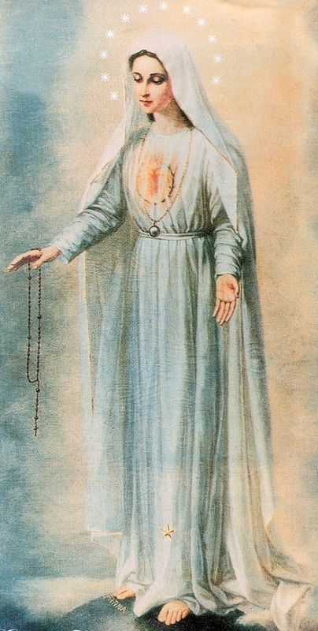

Consecration Preparation For the
Triumphant Victory of the
Immaculate Heart of Mary

An Archdiocesan Commission was formed in Denver, Colorado on December 12, 1991 to investigate the authenticity of the alleged apparitions of Our Holy Mother of Virtues. This investigation is continuing and no final judgment has been rendered as of the date of this publication. In all matters, we remain obedient to the Magisterium of the Church.

The following article, written by Father Dominik Maria, eloquently describes the call for the Triumph of the Immaculate Heart of Mary. We invite you through prayer, to discover the wonderful gift that Our Lady has given to us through the consecration to her heart for her Triumph. In living the spirit of this call and this intention, we invite you to prepare for your consecration in this way.

“In The End My Heart Will Triumph”
By Fr. Dominik Maria

There is no doubt that this is a crucial time in our lives. It is our belief that we are living in a most significant period of this century, and that we are entering into the times promised in Fatima – the time of the Triumph of Our Lady’s Heart.

This, our conviction, is strengthened by the many signs of the times that we are able to witness in the Church among the people of God, those who are humble and simple of heart and therefore able to listen to the Father.

First, we must look to Our Holy Father (John Paul II). He is a SIGN of this time. He is the light coming from the east, called from afar to lead the Church into this new era announced and promised in Fatima – The Triumph of the Immaculate Heart of Mary!

John Paul II is the Pope of Fatima in a special way. His blood was shed with an attempt on his life in St. Peter’s Square on the anniversary of the first apparition in Fatima, the 13th of May, 1981. After three years, on the 25th of March, 1984 he fulfilled the consecration requested to Sister Lucia by Our Lady of Fatima – the consecration of Russia and the world to the Immaculate Heart of Mary.

Another sign coming from the East is the big wonder of the breakdown of communism in Russia and in the East. Our Holy Father said, in his visit to Fatima in 1991, that it was Our Lady who led these oppressed nations into freedom.

Many people who believe in the message of Fatima prayed for this wonder to happen in consecrating themselves to Our Lady and in offering their daily sacrifices, prayers and crosses for the conversion of Russia, and so of the world.

In the beginning of this century, the heavens gave us the focus of the mission to be accomplished – The Triumph of Our Lady in Russia, and through Russia, the entire world. Thus, the central focus remains Russia.

To understand this global plan of peace relating to the conversion of Russia, we must achieve simplicity and humility of heart. If we believe that we must convert Russia and the east, we have the wrong conviction. Russia and the east will convert us! We need only to help Russia to be converted, and in these efforts to help, we will be the ones who will experience conversion.

In Fatima, Our Lady spoke of the “Triumph of the Heart”, thus a triumph that starts from the heart to reach other hearts; a Triumph that begins very deep in each of us; a Triumph manifested through the most wonderful fruit of the spirit, charity.

Charity of the heart is living in sacrifice as requested by Our Lord, a sacrifice that is nurtured by prayer and self-giving, by suffering and joy, by purity of heart and simplicity. It is given and not created, for it is a pure gift of God. The gift of charity is received in faith and is to be shared in humility. It is shared in humility to be received again, more precious than before, in joy.

“In the end my heart will triumph” is the heavenly promise given to us by Our Lady of Fatima in 1917 and is to be taken ever so seriously today by those who consecrate themselves to the Immaculate Heart of Mary. This plan, this call, to each one of us for the renewal of the Church (and so of the world) is The Triumph.

This plan of Our Lady is simple yet intense – like our YES. Our simple but intense YES given through our consecration to the Immaculate Heart of Mary, allows us to be put in her service, as an apostle for her Triumph. A YES, which is ready to accept the joys as well as the sorrows. There are many who speak often in “her name”, yet their own name remains on their lips. We must speak with “her words” – she must be allowed to speak through us! For this reason, to become an apostle for the Triumph, no title is needed, no curriculum vitae, no special relationship with any visionary, nor the quantity of books written or read, or talks given. The only request is to become her child, to give witness on every occasion, every time and everywhere, and to have the courage to have no agenda – she will do everything.

These specific graces of the Triumph will be given only when unity is found among Our Lady’s children. We must look to the example of Our Holy Father and the shepherds who are united with him. The unity we will experience in our hearts, among us, will be the most powerful sign of the Triumph of the Immaculate Heart of Mary. It is not important how many we are, how strong we are, or how much we can do – what is important is that we are one! When we are one heart can the Holy Spirit descend upon us. He can only come if He finds among us the same life, the same essence which is His Life – UNITY!

To achieve unity, we must abandon all the feelings of security that we have gained – we have to begin with the most simple task to reach the most difficult one. We have no time to look to the past, there is no time to complain – there is only time to say “yes” together to her plan. Let us come under the same guidance – Our Lady’s guidance. She is revealing herself in so many places, through so many people, in so many different ways – like a prism, having many different faces. Let us come together under her mantle. We have discovered the same mother, the same voice, the same call – The Triumph of Her Immaculate Heart. There is no place for distinction because this call comes above all other calls. This plan of the Triumph is above all other plans. This apostolate is above all others. It is a plan that cannot experience any division because it is a plan of global union. You must be able to be united to become an apostle for the Triumph.

Let us set aside our proprietary claims – “our magazine”, “our newsletter”, “our apostolate”, “our conference”, “our…” We must have only one claim – working together for the fulfillment of the secrets given at Fatima, secrets that will lead us into the perfect union between God and mankind.

In the beginning of the Church, the apostles were just twelve, but their strength was to have one heart and one mind. This was possible because Our Lady was in the center of their simple hearts. The vision they had was to have her in the center and everyone else around her. Our meeting room can become for us (we that feel the call for the triumph) our “upper room”. In this room we must enter in simplicity and humility of heart. Under her guidance, we will be able to initiate the most wonderful plans for her. In this place we must share the deepest intentions we carry in our hearts, and in this sharing we will understand how to move on. We have always tried solving problems by starting from the outside, searching for solutions. On the contrary, we must begin from the inside, for only within, our hearts can we reach other hearts. The Triumph is the work of hearts. The Triumph is a plan with the Cross as its center.

The time will come – and it is very close – in which Our Lady will give such power to those apostles for the Triumph that no one will be able to stop them. So let us take this wonderful opportunity to begin again and to accept that, though our efforts in “our apostolates” were good efforts, they were only human efforts. You will find joy in the suffering you endure for the plan of the Triumph. You will find and share in joy the humiliation of your nothingness. This is an apostle for the Triumph.

“Behold the handmaid of the Lord, be it done to me according to your word.” Luke 1:38

Dear brothers and sisters in Christ,

As each of us stand before God as His servant, we must seek to find His holy will within our lives. The Mother of God also comes to her children as the servant of the Lord, revealing to us His most ardent desires. This has been Our Lady’s constant role throughout the Gospel. She was chosen by God to bring to us the Light, Jesus our Redeemer. She brings to us only His wishes. As co-redemtrix, she is present among us today as never before, to lead us into the full understanding and fulfillment of the Gospel message.’

We life in a Marian century under the guidance of a shepherd, the Holy Father John Paul II, who is totally consecrated to her – Totus tuus. By his living example, he has shown us true humility in accepting the motherly call for her children; a call given long ago to three little children in a small village in Fatima: “God wants to establish in the word devotion and consecration to my Immaculate Heart”.
In Fatima, Our Lady revealed God’s most urgent desire for our times – the consecration to Our Lady’s Immaculate Heart. This request is given as the only possible remedy for bringing about the conversion of Russia and peace within the world. This message revealed incredible wonders to occur in this century, touching the realms of political, social and spiritual events. Today, we find the result of this consecration. With the fall of communism in Russia and the East, we see clearly the hand of God as given in the words of Our Lady in Fatima. It is this power of the consecration that has brought this miracle to us.

Communism is the greatest challenge that Satan has waged against God – the most intense persecution against the church and mankind. An apocalyptical flight within this century between the dragon and the woman clothed with the sun.

Our Lady came to Fatima to call all her children to partake in the greatest victory of history – the Triumph of Her Immaculate Heart in Russia, the land that Satan has chosen as the battleground. We know from the message of Fatima that Our Lady has linked together Russia and the future of the world. The near past has shown to us how true this is. The conversion of Russia will result in the conversion of the world. To achieve this conversion we should reflect back on the words in the Gospel: “may they be so perfected in unity so that they may be one as we are one; that the world will recognize that it was you who sent me”. John 17:23

The grace of this unity will come to the Church and the world through the consecration to the Immaculate Heart of Mary because she is the Mother of Unity. To her heart the Lord has entrusted this unity and peace of the world. We must become servants like her to be able to respond to this most ardent wish of oneness.

Our Lady asked as an example of the unity, that the Holy Father, joined with all the Bishops, consecrate Russia and the world to her. On March 25, 1984, the Holy Fahter fulfilled this request of heaven. Today, as children of God, we must unite in our total consecration and in all our efforts to bring to fulfillment the Triumph of the Immaculate Heart of Mary in Russia and within the world.

+Paul Maria Hnilica SJ, Titular Bishop of Rusado
November 1, 1993 – Denver, Colorado

