Sacred Heart of Jesus Parish : Bowmansville N.Y.

Upcoming Parish Fundraising Events in 2019:

Friday March 8th
Krolick’s Fish Fry : eat in or take out.
Fish, 2 sides, rye bread, butter and coffee.
Homemade slices of pie will be available for sale.

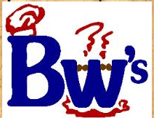 Friday April 5th
BW’s Fish Fry : eat in or take out.
Fish, 2 sides, rye bread, butter and coffee.
Homemade desserts will be available for sale.

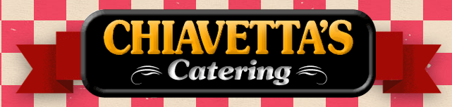 Wednesday June 12th
Chiavetta’s Chicken BBQ drive thru.
Chicken, 2 sides, roll and butter.
Our traditional drive thru event.

