The History of Sacred Heart of Jesus Parish
6. Our Pastors (Part 2)

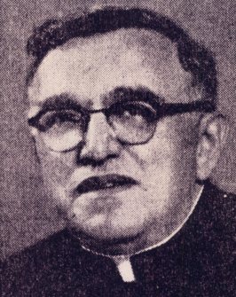
Following the death of Fr. Zeitz, Fr. John Richards was appointed pastor in June 1968. But Fr. Richards was already 65 years old and in declining health. He was able to serve only nine months before his health forced his retirement from active service as a priest. One legacy of Fr. Richards’ brief service was the Sunday folk Mass, which began during his time here.
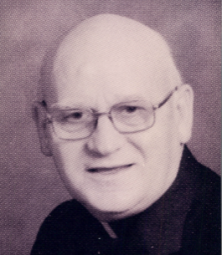
Fr. Lavern Kieber was appointed in March 1969 to succeed Fr. Richards. Fr. Kieber would serve for over 21 years, until his death on July 19, 1990 at age 73 – the longest tenure of any of our pastors to date. This was a period of stability in the parish, with few major changes. The closing of the school in 1983 was one of the more noteworthy events.
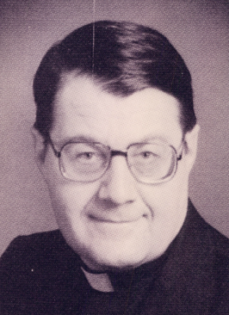
Msgr. Walter Kern was appointed pastor in September 1990. During the several years of Fr. Kieber’s declining health, few parish improvements had been made, and Msgr. Kern set out to upgrade the property and buildings, especially the shrine. With the parish’s 75th anniversary approaching in 1995, the church was repainted, with new carpeting, lighting and sound system. Msgr. Kern was an avid historian; he served as archivist for the Diocese and worked extensively on the history of Father Baker. By the early 2000s, Msgr. Kern’s memory was failing, and he retired from active service in 2002. Msgr. Kern died November 15, 2008 at age 78.
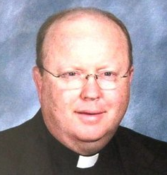
Fr. A. Mark Illig was appointed in April 2002 to succeed Msgr. Kern. Father Mark had a ministry of healing, and began a popular series of healing Masses at Sacred Heart; these eventually were held weekly, and were well attended. Fr. Mark suffered from diabetes, and his illness progressively worsened. By January 2011, he could no longer continue as pastor; he died December 11, 2011 at age 55.
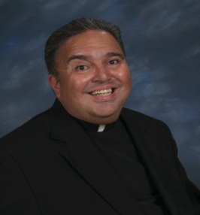
Msgr. Joseph Sicari was appointed pastor in April 2011, but his service would be brief. In August he had to take a medical leave, and in November 2011 it was announced that he would not be able to return.
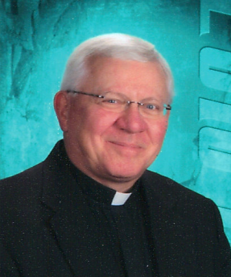
The loss of two pastors, both in their 50s, in less than a year, threatened the future of Sacred Heart parish. Priests were in short supply, and many parishes were being closed or consolidated. Fortunately, Msgr. Frederick Leising stepped forward in November 2011 and volunteered to serve as pastor of Sacred Heart in addition to his duties as pastor at Nativity, until a longer-term solution could be found. For a time, it appeared that we might be absorbed into Nativity parish, but Msgr. Leising was diligent in trying to find a better solution. He and Fr. John Leising served both parishes for well over a year. Eventually, Msgr. Leising convinced Bishop Malone that a priest who had duties at the Catholic Center downtown could also serve as Sacred Heart’s pastor, as our parish was not large and our location afforded easy access to downtown.
Around that time, a stroke of good fortune occurred. Father Joseph Klos, who served on the Diocesan Marriage Tribunal, came back from medical leave in Poland. He had gone to his homeland to recuperate from serious heart surgery, and his return to Buffalo had been in doubt. Fr. Joe readily agreed to accept appointment as our pastor in addition to his Tribunal duties; he began as our pastor in March 2013. He has brought new life to the parish, and we look forward to several years of his leadership.

