The History of Sacred Heart of Jesus Parish
1. The Founding of the Parish

We can trace our parish history to 1917, and possibly earlier. There were about 25 Catholic families in the Bowmansville area, along Genesee Street and on nearby farms. The closest churches were St. Mary’s in Lancaster and Our Lady Help of Christians in Cheektowaga. There was also Sts. Peter & Paul in Depew, but that was primarily a Polish-language parish. Thus the Catholics in Bowmansville found it hard to practice their faith, and some were sending their children to Sunday School at the Bowmansville Methodist church.
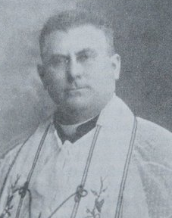
Two Bowmansville women were instrumental in encouraging the Diocese to establish a church in Bowmansville. Mrs. Pauline Hand, who by then had moved to Buffalo following her husband’s death, and Miss Anna Seiler, who lived on Maple Drive, regularly visited Bishop Dennis Dougherty to advance the cause. Finally, in June 1917, Bishop Dougherty agreed and asked Father Francis X. Scherer (see photo), pastor of Our Lady Help of Christians (OLHC), to also assume responsibility for a “mission parish” in Bowmansville. Documents incorporating the “Sacred Heart of Jesus Roman Catholic Church Society of Bowmansville, NY” were signed in September 1917 (Msgr. Nelson Baker – “Father Baker” – signed as Vicar General of the Diocese). We now existed on paper. We had a pastor, Fr. Scherer, and two trustees, Michael Cunningham and George Stephan. But we had no property and no church. A few months later, Bishop Dougherty was transferred to be the Archbishop of Philadelphia; it took almost two years before a new bishop was appointed.
A site for the parish was selected. It had once been the location of the home and office of Dr. Frank Gipple, a well-known local physician. His house was destroyed by fire in 1904, and the land had been vacant since then. Attempts to buy the land took a long time, as there were issues of title to be cleared up. Finally in March 1919, Father Scherer called a meeting of the Bowmansville Catholics at the home of trustee Michael Cunningham, who lived across the street from the parish site. In April 1919, the purchase of the Gipple land was finally completed. The site was about 300 feet wide and 264 feet deep – roughly from the main arch to the west boundary, where today the church, shrine, and about a third of the parking lot are. The land cost $2,000, which OLHC loaned us.
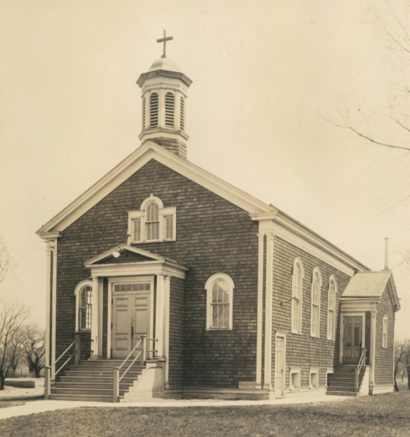
During the spring and summer of 1919, parishioners cleared the land and hauled in sand and gravel in preparation for the construction of a small church. Construction began in October 1919 and continued through the winter and spring of 1920. By summer 1920, the church was ready (see photo). The pews had not yet arrived, so chairs were used for several months. Construction cost $8,000, again loaned by OLHC. Buffalo’s newly-appointed Bishop William Turner dedicated the church on Friday June 25, 1920. This was his first church dedication as Buffalo’s bishop. About 30 other priests attended as well. A dinner at the Cunningham home followed the dedication.
Sacred Heart of Jesus parish was finally underway! We had about 35 parishioners. Sunday Mass was held at 9:00 A.M., and devotion to the Sacred Heart was held every First Friday. On August 21, 1920, the first fundraiser was held; a parish lawn fete netted $972. The 1920 parish financial report showed income of $2,968.28 and expenses of $12,461.46. Early financial reports listed each parishioner family by name and showed the amount of their contributions.

