The History of Sacred Heart of Jesus Parish
12. The Parish Cemetery

When the original church was dedicated on June 25, 1920, a cemetery was also consecrated. It is not entirely clear where the original cemetery was located. Some sources suggest it was where the front driveway is now, near the stone fence, while others suggest it was closer to the site of the shrine. In any event, it was west of the original church. The first burial, in December 1920, was Catharina Stephen, a 14-year-old girl who died in an accident.
The purchase of the rectory in 1923 included five acres of land extending back to Ellicott Creek. Part of this land would eventually become the current cemetery – but not until 1936.
In September 1936, the men of the parish cleared a driveway into the back land, so that the cemetery could be relocated to this larger site. The driveway ended in a circle in the middle of the cemetery area. There had been only a few burials in the original cemetery. Except for one or two, these were removed – with permission of the families – and reburied in the new cemetery. According to parish legend, a child’s grave remains in the original site.
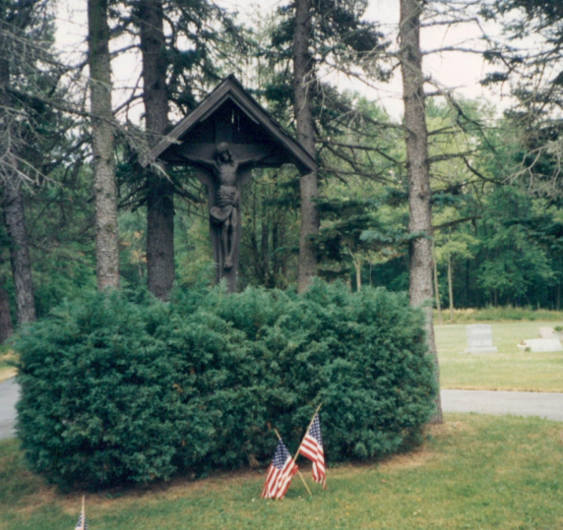
The new cemetery was not well maintained in its early years. Few gravesites were purchased, and there was little money for maintenance. In 1942, an effort was made to improve the cemetery. The mound in the center of the driveway circle had been bare. A large crucifix, 12 feet high (with another four feet in the ground) was installed in the circle, and landscaping was improved. The crucifix was made of red oak, and the figure of Jesus was carved in Switzerland, of Swiss maple. The crucifix was purchased from Carl Moser Inc. of New York City. It remains today as the centerpiece of the cemetery.
Following these improvements, parishioners Frank Reynders and Alfred Magrum kept the cemetery in good condition for many years, and the purchase of lots increased.
At one time, the cemetery land contained a natural gas well. Records show gas leases were signed in 1901, and then transferred around 1915 – before the parish bought the property in 1923 – to Iroquois Natural Gas Company (now National Fuel Gas). The well was 1,070 feet deep. It produced gas commercially for several years; the parish received royalties of $100 per year during the 1940s and into the 1950s. The well was plugged and abandoned in 1969.
In 1964, neighbors George and Margaret Lesser donated seven acres of back land to the parish. The large parcel, directly east of the cemetery, also has an 87-foot-wide strip of land extending to Harris Hill Road. This gift, though still undeveloped, offers the opportunity for future expansion of the cemetery as well as a possible access drive from Harris Hill Road.
Currently, our cemetery has about 1,500 gravesites, of which about 1,100 have been sold. We also have a 72-niche columbarium for cremated remains. About half of the columbarium niches have been sold to date.
Each year on Memorial Day, Mass is celebrated in the cemetery (weather permitting) to honor the veterans buried there, as well as the living veterans of the parish. This service is always well attended, and features the reading of the names of all veterans interred there, and the playing of Taps. As of Memorial Day 2015, there were 144 veterans buried in Sacred Heart Cemetery.
This concludes our series of monthly history articles, commemorating the 95th anniversary year of Sacred Heart of Jesus Parish. We hope you have enjoyed the information and memories about the parish’s first 95 years. We now look forward to our 100th anniversary in five years.
Ron Huefner, Parish Historian

